**MEMEBERSHIP IS FREE**

Every time you use your rewards card at any South Australian **Star Hotels** venues** you will earn points, receive discounted prices and enjoy member benefits like Venue competitions.

As well as earning points you will also get ranked into levels, the higher level you are the more bonuses you will receive.

There are 4 tier Levels Valued, Silver, Gold and Platinum.

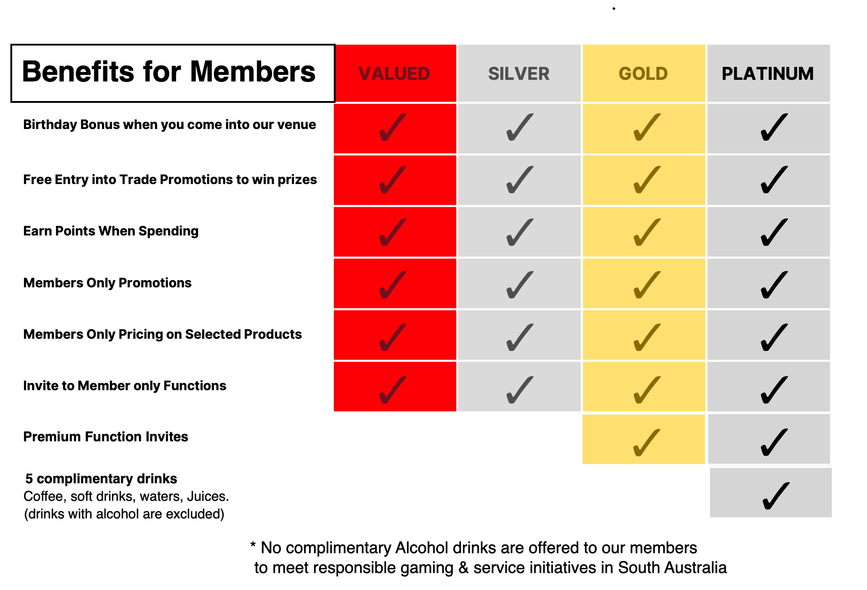

**star hotels venues are:

OG Hotel <https://oghotel.com.au/>

Click here for Loyalty Programs

Terms and Conditions

Holdfast Hotel <https://theholdy.com.au/>

Bombay Bicycle Club <https://bombaybicycleclub.com.au>

Avoca Hotel <https://avocahotel.com.au/>